

**ELECTRONIC DEVICES**



ARDUINO BASED RADAR SYSTEM

Submitted by-

Abhishek Tomar| Gautam Goel | Siddharth Parashar| Ritvik Bhatia

**INTRODUCTION**

**Abstract:** RADAR is an object detection system which uses radio waves to determine the range, altitude and direction of objects. The radar transmits pulses of radio waves or microwaves which bounce off any object in their path. Arduino is a single-board microcontroller to make using electronics in multidisciplinary projects more accessible. This project aims at making a RADAR that is efficient, cheaper and reflects all the possible techniques that a radar consists of.

*WORKING*

The project works on the principle of radar echo effect of the transmitting signal. Arduino control the servo motor for the direction of ultrasonic sensor and it moves from 0 degree to 180 degree.

Ultrasonic sensor transmits the signal in all direction and if any obstacle

that is target is detected then echo pulse sense. With the help of this echo pulse arduino program find out the distance and direction angle of the target ,

On the screen of Laptop.

* 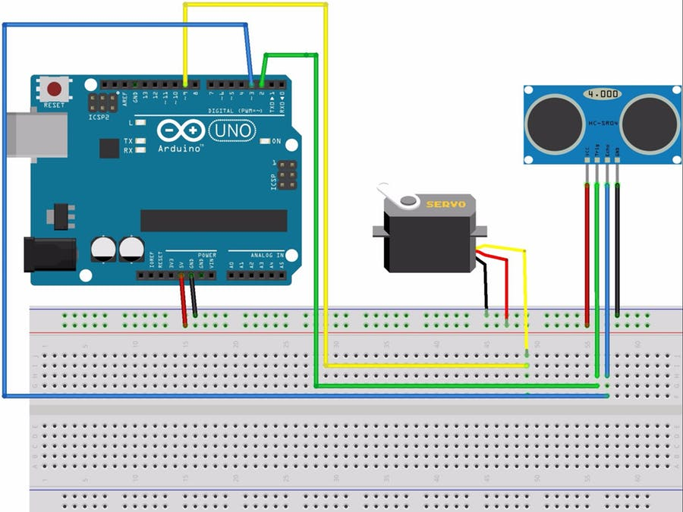

Here,

* Servo Motor,Ultrasonic Sensor, have their Postive and negative terminal common to Arduino’s pin having VCC=5v and Ground
* Trig is connected to Pin 10, Echo to Pin 11, and Servo motor to Pin12

**CIRCUIT SCHEMATIC**

* ARDUINO UNO

**COMPONENTS USED**

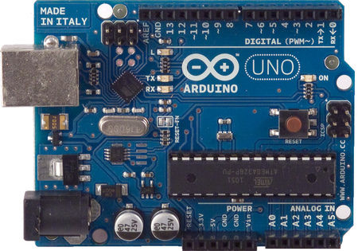

 The Arduino microcontroller is an easy to use yet powerful single board computer that has gained considerable traction in the hobby and professional market.

[1] Operating Voltage 5V

[2]Input Voltage (recommended) 7-12V

[4] Digital I/O Pins 14 (of which 6 provide PWM output)

[5] Analog Input Pins 6

* 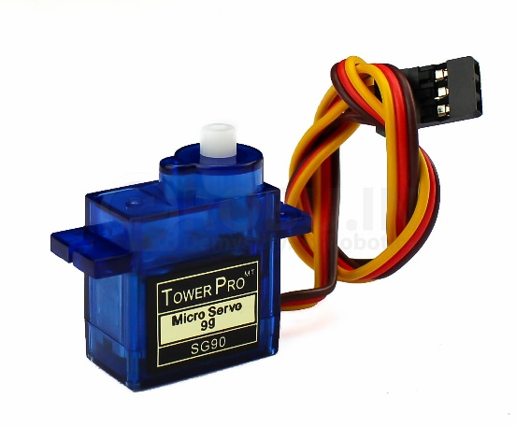SERVO MOTOR

A servomotor is a rotary actuator that allows for precise control of angular position, velocity and acceleration. It consists of a suitable motor coupled to a sensor for position feedback.

* ULTRASONIC TRANSMITTER AND RECIVER

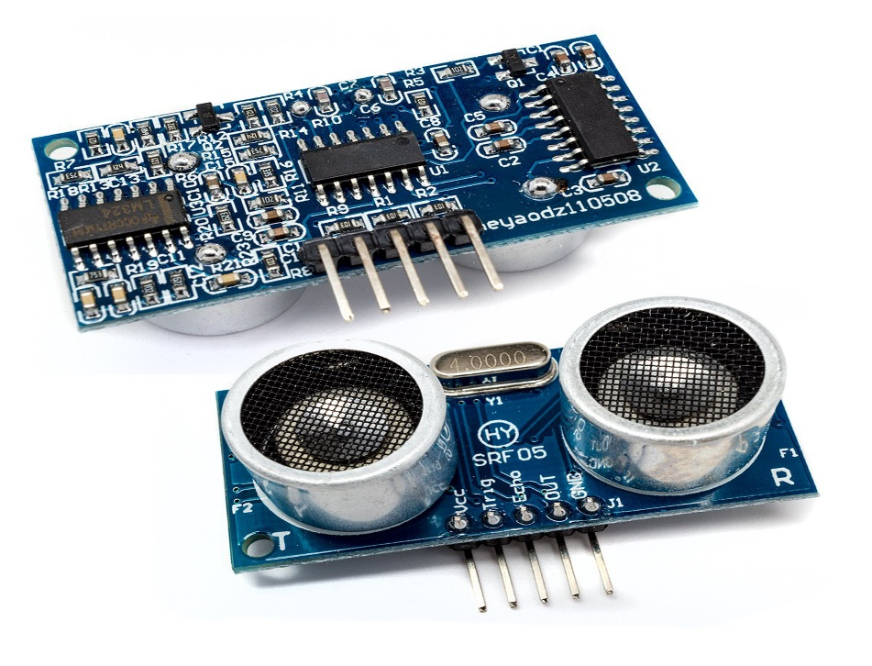

➢ Ultrasonic sensors (also known as transceivers) work on a principle similar to radar or sonar which evaluate attributes of a target by interpreting the echoes from radio or sound waves respectively.

➢ Ultrasonic sensors generate high frequency sound waves and evaluate the echo which is received back by the sensor

**FEATURES**

➢ Use for motion or distance sensing

➢ Frequency: 40kHz ±1.0kHz

➢ Aluminum case

➢ Capacitance: 2000Pf ±20%

➢ Transmitter: bandwidth 5.0kHz

* **PRINTED CIRCUIT BOARD(PCB)**

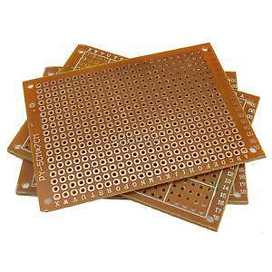

A printed circuit board (PCB) mechanically supports and electrically connects [electronic components](https://en.wikipedia.org/wiki/Electronic_components) or [electrical](https://en.wikipedia.org/wiki/Electrical) components using [conductive](https://en.wikipedia.org/wiki/Electrical_conductor) tracks, pads and other features [etched](https://en.wikipedia.org/wiki/Industrial_etching) from one or more sheet layers of copper [laminated](https://en.wikipedia.org/wiki/Laminated) onto and/or between sheet layers of a [non-conductive](https://en.wikipedia.org/wiki/Insulator_(electricity)) [substrate](https://en.wikipedia.org/wiki/Substrate_(electronics)). Components are generally [soldered](https://en.wikipedia.org/wiki/Soldering) onto the PCB to both electrically connect and mechanically fasten them to it.

*APPLICATIONS OF RADAR SYSTEMS*

1.Air Force

2.Naval Application

3.Applications in Army

4.COMMERCIAL AVIATION

5.DETECTION OF WRECKAGE UNDER THE SEA